**Chapter 7**

**TESTING**

Software Testing is the process used to help identify the correctness, completeness, security and quality of the developed computer software. Testing is the process of technical investigation and includes the process of executing a program or application with the intent of finding errors.

**7.1 Unit Testing**

Unit testing is a level of software testing where individual units/ components of a software are tested. The purpose is to validate that each unit of the software performs as designed. A unit is the smallest testable part of any software. It usually has one or a few inputs and usually a single output. Unit testing has been done to check whether the cancer dataset is loaded correctly.

* In table 7.1 to check whether the dataset is loaded accordingly as the output shown in figure 7.1.

**Table 7.1 Unit test case for Dataset Loading**

|  |  |
| --- | --- |
| Sl No. of test case: | 1 |
|  |  |
| Name of test: | Check test |
|  |  |
| Item / Feature being tested: | Input Dataset |
|  |  |
| Sample Input: | Syntax to display top 5 element from dataset specified in |
|  | a particular directory |
|  |  |
| Expected output: | Displays top 5 elements |
|  |  |
| Expected output: | Displays top 5 elements |
|  |  |
| Remarks | Test Succeeded |
|  |  |

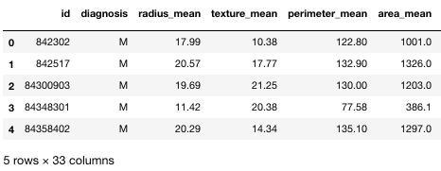

**Figure 7.1 Dataset Loaded**

Department of CSE, RNSIT 2018-2019 34